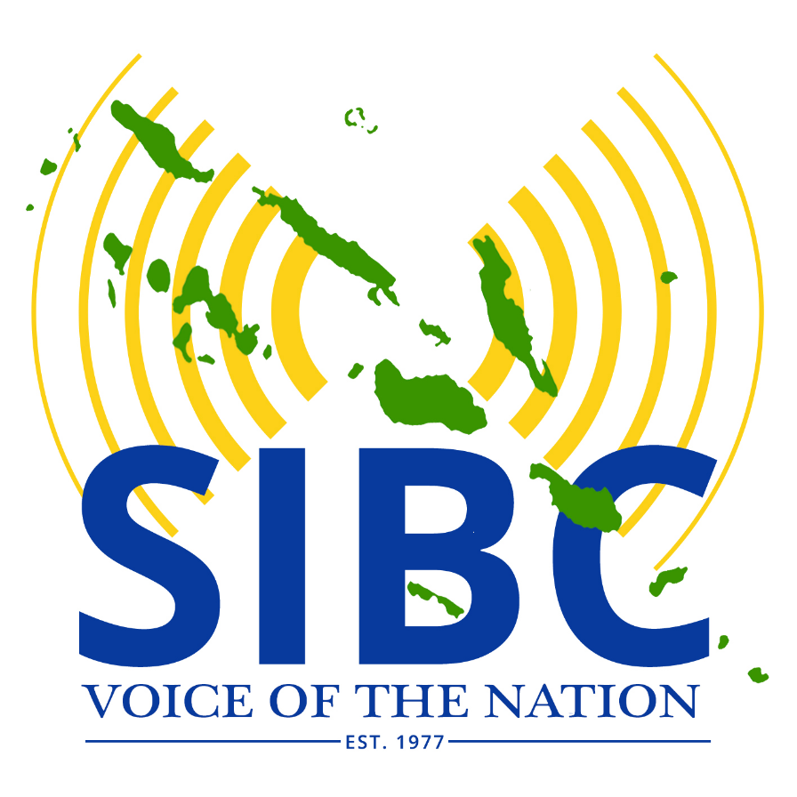

SIBC ANNUAL REPORT 2017

**INTRODUCTION**

The National Broadcaster operates under the authority of

* the Broadcasting Act Cap 112 of 1977
* the State Owned Enterprises Act of 2007
* and other laws such as the Essential Services Amendment Act no. 10 of 1986 which includes Broadcasting as an ‘essential service’.

SIBC is a long-serving national broadcaster which has successfully overcome problems that impacted all State Owned Enterprises (SOE) in the past twenty five years. The enactment of the SOE legislation in 2007 began the process of reform and since 2013 the Directors of SIBC have restructured and transformed SIBC to be on par with media organisations globally. This includes planning for the transition to digital technology, installing new business systems, instilling staff discipline, updating all job descriptions and actively utilising the Internet which has profoundly changed the global business landscape.

The reforms were successfully implemented and impacted positively on the financial position and operational performance of the Corporation. The Prime Minister - who has portfolio responsibility for Broadcasting - and the Minister of Finance and Treasury who is joint Accountable Minister for SIBC under the SOE Act recognise the performance turnaround of SIBC and supported the endeavour to serve people with a national free-to-air television service.

In 2013, 2014, 2015 and 2016 the Corporation made operational surpluses but could not declare profits because of unpaid debts (mainly for electricity) from previous years. In 2016 and 2017 the Corporation’s Financial Statements were given a clean bill of health by the Auditor General.

*Directors.* In 2017 the Directors of the SIBC were Mr. Robert L. Iroga, Mrs. Kathy Nori, Mrs Christina Bakolo, Mrs. Ella Kauhue, Dr. Alpheaus G. Zobule and Mr. Eric Chow. There was one vacant Directorship which will be filled in 2018.

At post in 2017 were a total of 45 staff, 40% of whom were female.

**MISSION**

SIBC’s mission is to provide Solomon Islanders and residents with free daily access to up-to date and reliable information, to help expand their education and provide professionally produced entertainment programs broadcast on quality equipment and transmitters. In this mission, SIG supports the SIBC by paying SIBC to provide for what it considers its (SIG’s) Community Service Obligations (CSO).

The services broadcast and loaded onto it website include useful information on matters affecting peoples’ quality of life, governance, livelihoods, commerce, cultural wellbeing, health, safety and security in times of emergency or disease outbreaks and for development purposes generally.

**PLATFORMS FOR SERVICE DELIVERY**

Apart from radio broadcasts on shortwave (long distance) analogue frequencies and the plan to introduce Television, SIBC also has other service delivery platforms and others are planned.

A start has been made to provide CD-quality FM transmissions in provincial capitals. FM transmitters are on air in Gizo, Honiara and Lata and others are to be installed in coming months and years. This will enable provincial broadcasters to employ local dialects in their programming.

sibconline.com.sb is the SIBC website which also contains a daily news bulletin, advertising and an FB page. Podcasts are also created.

SIBC streams its radio programs online which people with computers can receive anywhere in the world. It is also planned to stream the TV output.

The International Telecommunications Union (ITU) of the UN requires all countries to switch off their analogue and utilise digital transmissions instead by 2020.

As soon as digital radio receivers are available commercially SIBC will switch from analogue to digital transmissions which can provide several channels per frequency simultaneously thus providing listeners, viewers and advertisers more choice.

This will enable SIBC to provide separate programs in Pijin and English separately, and also in dialects. Digital transmissions use lower power consumption and provide CD quality reception wherever they are received.

**SIBC PERFORMANCE IN 2017**

The national broadcaster provided all of Government’s Community Services Obligations (CSO) as specified in the CSO contract and also served the business community with commercials and sponsored programming, as well as information programs for NGOs, women’s and youth organisations and also sports.

In providing services to the general public, the SIBC charges for commercial advertising and sponsorships and also panel discussions and talk back on important national issues. Sometimes matters of importance are provided without sponsors when none are available. In this case we consider the information provided to listeners as part of SIG’s community service obligations.

Some touring was carried out but this was limited by shortage of funds. Nonetheless the Central Islands of Savo and the Russells group were visited. The plan to tour Temotu province was postponed to 2018. After the Temotu tour, SIBC teams will again tour Isabel, Western, Choiseul, Malaita, Guadalcanal Makira, Renbell and central island provinces.

*2017 Statement of Corporate Objectives (SCO).* This was submitted to MoFT in late 2016 as per the SOE Act and from this was developed the Television and Broadcasting Community Service Obligation (CSO) contract signed by the Minister of Finance to pay SIBC $5,000,000 in 2017. Copies of the SCO and the CSO for 2017 are attached.

*Contingency Planning.* In mid-2017 SIBC noted that SIG was having difficulty paying its bills for services rendered and drew up a contingency plan in case SIG became insolvent thereby rendering SIBC insolvent as well.

*Revenue dries up.* Increasingly MoFT was unable to pay SIBC invoicing and several productions and projects were slowed down or halted. One of these was the National Television project which we now hope to revise down to a low level launch in 2018.

*MoFT default.* In November MoFT announced that it was defaulting on the agreed CSO contract and would not pay the second tranche of the CSO payment. So the SIBC was short of its budget by $2.5m and when the accounts for the year were completed the Corporation had made an operational loss of $330,000 for the year.

*SIEA cuts power to SIBC*. The last month of the year saw SIEA the electricity provider switching off SIBC studios power on the 15th of December claiming SIBC had not paid its invoices in full. After a few days it was discovered that it was SIEA which had not paid an SIBC invoice. Cheques were exchanged and relations between the two Essential Services was restored.

However this did not mean SIBC was financially sound. MoFT was still unable to pay its bills and SIBC had to launch Phase 1 of its Contingency plan. This involved switching off its Medium Wave transmitter to try and save close to $30,000 monthly. This created a furore as many people close to and in Honiara were still listening to MW and not to the FM service. It was agreed to keep the MW transmitter off air and study the situation in February 2018.

The year ended with SIBC and the nation wondering what the immediate future would bring as by then SIG had announced it had a major cash flow crisis and did not have sufficient finances to meet its commitments.